**U.S. hurricanes used to be given only female names, a practice that meteorologists of a different era considered appropriate due to such characteristics of hurricanes as unpredictability. This practice came to an end in the late 1970s with increasing societal awareness of sexism, and an alternating male-female naming system was adopted. Even though the gender of hurricanes is now preassigned and arbitrary, the question remains: do people judge hurricane risks in the context of gender-based expectations? From previous research, it was found that severe hurricanes with feminine names were associated with significantly higher death rates than hurricanes with masculine names. In this project, you will use exploratory data analysis (EDA) and descriptive statistics to investigate if female Hurricanes are deadlier than male hurricanes.**

*Tasks:*

1. **Introduction:**

*The objective of this project is to investigate whether hurricanes with female names are deadlier than those with male names. We will perform an exploratory data analysis using descriptive statistics and visualization to explore the relationship between the gender of hurricanes and the number of fatalities. By analyzing the differences in death tolls between male and female-named hurricanes, we aim to determine if gender expectations might influence the severity or perception of hurricanes.*

1. **Data collection and data description:**

**First:**

**Hurricane Year Gender Number_of_Deaths**

1 Easy 1950 Female 2

2 King 1950 Male 4

3 Able 1952 Male 3

4 Barbara 1953 Female 1

5 Florence 1953 Female 0

6 Carol 1954 Female 60

7 Edna 1954 Female 20

8 Hazel 1954 Female 20

9 Connie 1955 Female 0

10 Diane 1955 Female 200

**Last:**

**Hurricane Year Gender Number_of_Deaths**

83 Ophelia 2005 Female 1

84 Rita 2005 Female 62

85 Wilma 2005 Female 5

86 Humberto 2007 Male 1

87 Dolly 2008 Female 1

88 Gustav 2008 Male 52

89 Ike 2008 Male 84

90 Irene 2011 Female 41

91 Isaac 2012 Male 5

92 Sandy 2012 Female 159

1. **Classification of data:** Which variables are quantitative, and which are

qualitative/categorical in your data?

*Qualitative*--> Names, Gender, Year

*Quantitative-*-> No of Deaths

1. **Visualization of Data:**

**Center**: *The median number of the deaths appear to be roughly the same for female-named hurricanes compared to male-name ones.*

**Spread:** *Female hurricanes seem to have a wider spread, indicating more variability in the number of deaths.*

**Shape:** *Female-named hurricanes display a more skewed distribution with potential outliers at the high end, indicating severe events.*

**Conclusion:***Based on this initial visualization, it seems that female-named hurricanes could potentially be more severe in terms of fatalities.*

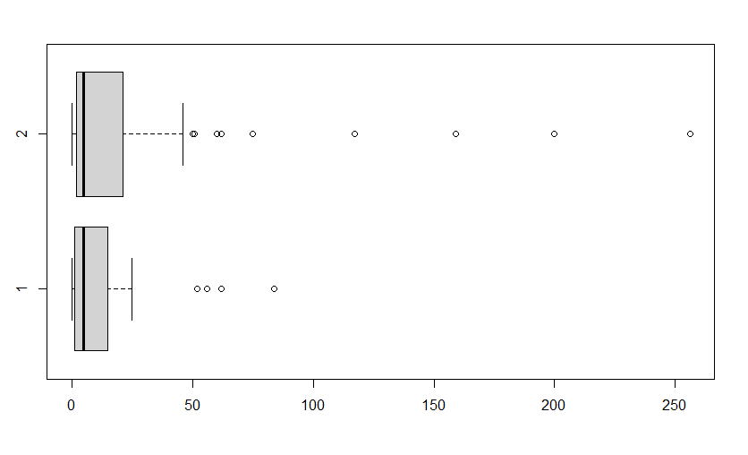

**Male Female**

1. **Numerical summary Measures:**

**Female:**

Min. 1st Qu. Median Mean 3rd Qu. Max. Stan. Dev.

0.00 2.00 5.00 23.76 21.00 256.00 47.4662

**Male:**

Min. 1st Qu. Median Mean 3rd Qu. Max. Stan. Dev.

0.00 1.25 5.00 14.23 15.00 84.00 21.1622

1. **Best measure of center and spread:** Which measures of center and spread better represents a typical number of deaths from a hurricane and why? Explain. No R needed.

*Given the skewed nature of the data, the median is likely a better measure of the center, as it is less affected by outliers. For spread, the interquartile range is preferable, as it focuses on the middle 50% of the data and is less influenced by extreme values compared to standard deviation.*

1. **Outlier detection:** For each of the Female and Male named hurricanes, determine whether there are any ***mild*** or ***extreme*** outliers. Which ones?

**Male:**

Mild: 62 56 52 84

Extreme: 62 84

**Female:**

Mild: 60 200 50 75 256 117 51 62 159

Extreme: 200 256 117 159

1. **Which hurricanes are deadly?** Based upon your numerical calculations, do you think that the Female named hurricanes are more deadly? Use all the numerical summary statistics. No R needed.

*Female hurricanes are statistically more deadly, as the data suggests. Since the female-named hurricanes tend to have more fatalities, indicated by higher means and greater variability in death totals.*

1. **Examining the Effect of outliers in a data set:**

**Center**: *The median number of the deaths appear to be the same for female-named hurricanes compared to male-name ones.*

**Spread:** *Female hurricanes seem to have an extremely wider spread, indicating more variability in the number of deaths.*

**Shape:** *Female-named hurricanes display a more skewed distribution with potential outliers at the high end, indicating severe events.*

**Conclusion:***Based on this initial visualization, it seems that female-named hurricanes could potentially be more severe in terms of fatalities, by adding the two extra data points makes it more likely.*

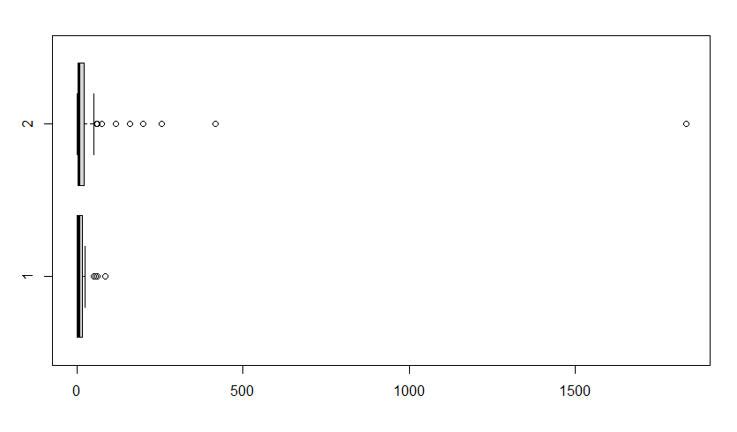

**Male Female**

**Female:**

Min. 1st Qu. Median Mean 3rd Qu. Max. Stan. Dev.

0.00 2.00 5.00 58.16 22.00 1833.00 235.3288

**Male:**

Min. 1st Qu. Median Mean 3rd Qu. Max. Stan. Dev.

0.00 1.25 5.00 14.23 15.00 84.00 21.1622

**Male:**

Mild: 62 56 52 84

Extreme: 62 84

**Female:**

Mild: 60 200 75 256 117 62 159 416 1833

Extreme: 200 256 117 159 416 1833

Female hurricanes are still statistically more deadly. However, by adding those two rows the data more clearly shows that the female hurricanes have a higher number of deaths.

1. **Bias in Results:** Do you think ‘the fact that all hurricanes had Female names until 1979’ bias the results? Explain. No R needed.

The fact that all hurricanes were assigned female names until 1979 could introduce a bias, as there might be a historical underreporting of male hurricanes or differences in naming conventions over time. This might skew perceptions and outcomes in favor of finding female-named hurricanes deadlier.

1. **Conclusion:** Write a conclusion about the research question asked in this project and results found in no more than 5 sentences.

*In conclusion, this analysis shows that the gender associated with the hurricane’s name is correlated with the number of fatalities suffered. Whether influenced by perception of fatality, or by naming conventions, the correlation is apparent. Hurricanes receiving female names have higher numbers or fatalities on average, as well as higher number of outliers past the upper fence in particular.*